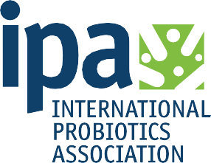
October 15-19, 2019 · Expo Hall 17 & 18 Madalay Bay, Las Vegas

INTERNATIONAL PROBIOTICS ASSOCIATION
PROBIOTICS GUIDE
SUPPLYSIDE® WEST 2019

The definitive Probiotics Guide to SupplySide® West, including exhibitors, presentation schedules, and more!

For the full experience visit Probiotics Resource Center:

© IPA | The Global Voice of Probiotics®

THE GLOBAL VOICE WHICH NEVER RESTS IPA PROBIOTICS GUIDE

Welcome to the second edition of IPA’s probiotics guide published for the Supply Side West Show
/ Fi North America in Las Vegas and in tandem with the Probiotics Resource Center. I will take this opportunity to mention our resource center has grown yet again, hosting a wealth of probiotic knowledge, learning and networking opportunities.

The global probiotic industry continues to grow at a fervent pace. Forecasts are still online to reach over USD $50 billion where dietary supplements will account for over USD $7 billion by 2023.

IPA’s continues to work for all stakeholders of the sector. Some of the consumer research we conducted this year shows that 74% of probiotic users prefer to pay for quality; IPA just recently published manufacturing guidelines to ensure probiotic product quality. We also saw that physician influence is the top purchase driver for probiotic products; IPA’s education and commu- nication committee is designing a series of infographics and education webinars targeting those main influencers among others. To finish 74% of probiotic users are concerned about misinformation and false claims; IPA’s scientific committee is working on a clinical trials tool in order to make sure the benefits are ultimately properly communicated.

IPA’s blue sky vision is to eventually support probiotic regulations befitting all regions of the globe. IPA works diligently, on a country specific basis to try and understand the different requirements, and then enter into dialogue, with the different governments authorities globally.

HAVE A VOICE If your company wants to join the global community of probiotic companies which make up the IPA’s membership, and help shape the IPA’s mission of promoting the safe and efficacious use of probiotics throughout the world, then visit with us at Stand #5646 during the Supply Side West Show/Fi North America in Las Vegas to discuss your contribution and joining the unified Global Voice of Probiotics® around the world.

George Paraskevakos, MBA
EXECUTIVE DIRECTOR, IPA

george@internationalprobiotics.org www.internationalprobiotics.org

STATISTICS PROVIDED BY:

2 | IPA Probiotics Guide Introduction

@

Rising consumer health concerns contribute significantly to the growth of the probiotics market; meanwhile increasing amounts of disposable income and standards of living will benefit the overall market. There are real business opportunities for probiotic manufacturers looking to provide products to help manage illness and promote overall health and wellness.

Discover the latest breakthroughs in probiotic technology, new product development, consumer analysis, and market trends through the exhibitors, a presentation theater and infographics in the Probiotics Resource Center (PRC) at SupplySide® West 2019!

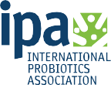
Sponsored by:

Contents
04 PRC Featured Exhibitors 07 PRC Theatre Schedule 14 SSW Floor Map 16 IPA Member Probiotics Trail 17 IPA Insights: Education 19 IPA Insights: Scientific Development 20 IPA Infographics 25 IPA Current Member Companies 27 IPA Probiotics Guide Contributors

Table of Contents | 3

FEATURED EXHIBITORS BOOTHS A-E

Fluid Air Booth 5646-A
Fluid Air specializes in developing equipment for the modification/creation of powders and particles & providing customized solutions to solid dosage process challenges across industries including pharmaceuticals, foods, & probiotics. Through a combination of core-shell microencapsulation and the electrostatic effect utilized in our PolarDry® Electrostatic Spray Dry Systems, we can provide greater encapsulation efficiency, superior morphology, and longer shelf-life which will eliminate the need for traditional and/or secondary agglomeration operations. As a result, Fluid Air has emerged as a leader in the global process community with well-established reputation for best-in-class service.

Blis™ Booth 5646-B
BLIS™ is a manufacturer of advanced probiotic strains for specific health targets including throat health, halitosis (bad breath), immune support and teeth and gum health. Combining innovation with evidence-based research has enabled the company to develop a range of products containing two strains of probiotic bacteria - BLIS K12™ and BLIS M18™. Both of these strains occur naturally in the oral cavity however, only a small proportion of the population have these healthy bacteria at levels high enough to be effective. BLIS™ products have received regulatory approvals for sale in New Zealand, Australia, Asia, Europe, Canada and the USA.

MeriCal Booth 5646-C
Driven by innovation. United in the pursuit of wellness. We are leaders in the probiotic space with over 40 years of formulation experience with both lactic acid and spore forming bacteria. Our state-of-the-art, dedicated Probiotic Suite allows us to manufacture and package probiotics in exceptional temperature and humidity controlled conditions. We are committed to provide consumer guidance and recently launched the first ever USP Certified Probiotic. We are a premier source for custom contract manufacturing & packaging and innovative dietary supplement solutions – with a recent certification to manufacture organic vitamins and probiotics.

Amin Talati Wasserman Booth 5646-D
Amin Talati Wasserman LLP is one of the nation's leading regulatory and intellectual property law firms with offices in Chicago and Washington, D.C. The firm represents a sophisticated client base
— including Fortune 500, middle-market and emerging companies — in the food, dietary supplement, pharmaceutical, cosmetic and medical device industries With deep experience in probiotics and other product categories, its services include: FDA compliance (labeling; manufacturing); NDI/GRAS ingredient analyses; clinical trial design; patents and trademarks; customs clearance and class action defense.

UAS Labs Booth 5646-E
UAS Labs is focused on one thing and one thing only - probiotics. It’s all we do; it’s all we’ve ever done. Since 1979, our dedication to excellence has brought together a team of experts with over
100 years of combined probiotic experience. This team has engineered one of the only fully-integrated probiotic manufacturing processes in the world. From strain to solution, every step in the process is meticulously performed to maintain product viability and to ultimately deliver a health benefit to the end-consumer. It’s easy to see how we’ve earned our name as The Probiotic Company®.

4 | PRC Featured Exhibitors

FEATURED EXHIBITORS BOOTHS F-J

BioCC Booth 5646-F
BioCC LLC is a bioscience company focused on comprehensive and high-quality R&D. Portfolio of BioCC contains a range of probiotic products comprising of clinically validated patented multi-potent anti-inflammatory, antioxidative Lactobacillus spp. strains (TENSIA®, INDUCIA® and MCC1®) under the Nordwise® brand for cardiovascular health (lowering blood pressure, cholesterol levels, reducing oxidative stress etc.), supporting gut health and immune system.

Prenexus Health Booth 5646-G
Prenexus Health offers prebiotic ingredients supported by scientific and clinical research. Prenexus Health believes that understanding digestive health and establishing healthy gut microbiota is important for life-long health & wellness. Prenexus Health's mission is to improve the health & wellness of individuals, through the manufacture of its XOS Prebiotic that is grown and processed in the U.S. following organic environmental practices.

RNI Consulting Booth 5646-H
Regulatory solutions to support your research and development efforts on a global scale. RNI Consulting, an international regulatory and scientific consulting firm, provides specialized expertise in regulatory strategy development and solutions. For over 15 years, our team has provided strategic guidance and scientific support for the regulatory compliance of food ingredients, dietary supplements, dietetic products, health products, medical devices and cosmetics. With offices in the US, France and the United Kingdom, RNI provides solutions that support research, development and product launches on a global scale. For more information on how RNI Consulting can support your company’s development efforts: Visit our website at www.rni-consulting.com or Call us at 888-407-5668.

IPA Booth 5646-I
The International Probiotics Association (IPA) is a global non-profit organization bringing together through its membership, the probiotic sector’s stakeholders including but not limited to academia, scientists, health care professionals, consumers, industry and regulators. The IPA’s mission is to promote the safe and efficacious use of probiotics throughout the world. Holding NGO status before Codex Alimentarius, the IPA is also recognized as the unified Global Voice of Probiotics® around the world.

Nutrasource Booth 5646-J
Nutrasource Pharmaceutical and Nutraceutical Services is a premier, vertically-integrated global regulatory consulting, clinical research, and product testing firm that brings unparalleled expertise in nutrition, regulatory affairs, and pharmaceutical science to help our clients achieve compliance and gain market entry. To learn more, visit our website at www.nutrasource.ca.

PRC Featured Exhibitors | 5

Your Probiotic Partner, from culture to claim.

VISIT US AT BOOTH 5646-J

Nutrasource is a global CRO that helps launch products with strong science and regulatory confidence. To learn more, visit us online at www.nutrasource.ca.

Thursday, October 17th

10:00
Expo Hall Opens

10:30 - 11:10

Impact of a Finalized NDI Guidance to Probiotics
Dr. Corey Hilmas, MD, Ph.D.
Chief Regulatory Officer, KGK Science

- Safety assessments for live microbial ingredients.
- Identity considerations.
- What to expect in the NDI Finalized Guidance for Industry.

11:20 - 12:00

Next Generation Prebiotic Technology
Dr John Deaton, Ph.D.
Vice President of Science and Technology, Deerland Probiotics & Enzymes

- The evolving market for prebiotics and the innovative mechanisms of action beyond traditional fibers and starches.
- Clinical results demonstrating how a bacteriophage cocktail modulates the microbiome without disrupting global microbiota, and the systemic effects that result when beneficial bacterial species are able to proliferate.

12:10 - 12:50

Identifying the Global Whitespace for Probiotic Products
Dr. Don Cox, Ph.D.
R&D Director, Kerry ProActive Health

- The growth areas in the probiotic food and beverage space.
- The benefits of doing your research when searching for a probiotic strain.
- The science behind digestive and immune benefits.

13:00 - 13:40

Clinical Research, Changing the Probiotic Landscape
Dr. Gregory Leyer, Ph.D.
Chief Scientific Officer, UAS Labs

- Clinical research and its importance within the probiotic space.
- Outcomes measured in studies evaluating IBS symptoms.
- Results from UAS Labs’ most recent clinical study involving >300 adults with IBS.

PRC Theatre Schedule | 7

Thursday, October 17th

13:50 - 14:30

SYNKEFIR™ – New Innovation in Postbiotics for Functional Foods
Wen-Shiaw Lan
Overseas Affairs Manager, Synbio Tech

- Kefir: one of oldest probiotics with health-promoting benefits.
- The important role of bacterial metabolites in the human gut.
- An emerging field of research and application in functional foods and sport nutrition.

14:40 - 15:20

SynBalance® Probiotic Complex Against Metabolic Syndrome. A Potentially New Ally in the Public Health Preventive Approach to Metabolic and Cardiovascular Risk?
Dr Cristiana Piangiolino, Ph.D.
Marketing Manager, Nutraceutical & Food, ROELMI HPC

- Reduction of metabolic syndrome prevalence and cardiovascular risk factors.
- Improvement of markers of insulin resistance and self-perceived healthy status.
- Decreased markers of systemic inflammation.

15:30 - 16:10

ComboCap®’Biotics by Lallemand
Bérengère Feuz
Marketing Director, Lallemand Health Solutions

- Presentation of the technology.
- Features and Benefits.
- Examples of possible formulas and possible claims.

16:20 - 17:00

Probiotic Product Development – Considerations, Challenges, and Evaluation for Market Acceptance and Quality
Mehgan Styke
Business Development Director, Eurofins

- Ingredient Selection and Evaluation as Single Strains vs. Blends.
- Formulation in Pilot and Scale-up.
- Label Creation and Evaluation.

17:30
Expo Hall Closes

8 | PRC Theatre Schedule

Friday, October 18th

10:00
Expo Hall Opens

10:30 - 11:10

L. plantarum INDUCIA® as Enhancer of Cellular Immunity, Hypocholesterolemic and Anti-Oxidative Agent and Anti- microbial Agent Against Clostridium difficile
(USA Patent US10272122)
Dr Kersti Ehrlich-Peets Liina Kuus, M.Sc. student
Senior Researcher, BioCC LLC Manager of Production and Clinical Trials

- Lactobacillus plantarum INDUCIA® helps to maintain cardiovascular health.
- Proven by clinical trials - reduces levels of important risk factors of cardiovascular diseases: cholesterol and oxidized LDL.
- Antagonistic activity of L. plantarum INDUCIA® against vegetative cells of C. difficile.

11:20 - 12:00

Immune Boosting Probiotics
Dr. Ralf Jäger, FISSN, CISSN, MBA
Senior Scientific Advisor, Ashland

- Beauty from within: oral skin care probiotics.
- The role of probiotics in food allergies.
- Can probiotics help people with asthma?

12:10 - 12:50

The Effects of Probiotic Supplement, Bacillus coagulans Unique IS2 on Protein Absorption in Resistance Trained Adult Males
Dr Jayanthi Neelamraju, Ph.D.
Manager–Scientific Affairs, Unique Biotech Ltd

- Absorption of branched chain amino acids leucine, isoleucine, and valine after whey protein supplementation.
- Absorption of other amino acids such as Aspartic acid, Glutamic acid, Serine, Threonine, Tyrosine, Methionine and hydroxyproline were increased.
- Muscular strength and power as evidenced by Repetition Maximum (RM) of leg press and vertical jump.

13:00 - 13:40

Using Data Science to Drive Innovation in the Probiotics Industry
Joshua Baisley, H.B.Sc.
Vice President of Clinical Design and Delivery, Nutrasource

- How to effectively pool scientific data.
- The importance of aggregating information to optimize claims.
- Provide key feedback information for new product development.

PRC Theatre Schedule | 9

Friday, October 18th

13:50 - 14:30

Processing Probiotics
Robert Sakhnovsky
Product Specialist, Fluid Air

- Microencapsulation.
- Electrostatic.
- Temperature Sensitive Materials.

14:40 - 15:20

Understanding the U.S. Probiotic User – An IPA Perspective
George Paraskevakos, MBA
Executive Director, International Probiotics Association

- How new entrants cannibalize a market.
- Education can go a long way in product development and sales.
- And quality always wins over price every time.

With all the reports about probiotic market growth in the US slowing down, the industry is trying to understand what all this means. Like any market correction, all this means is there is an opportunity for the industry to become stronger on product innovation and science.

16:20 - 17:00

IPA Comedy Show Featuring Ivan Wasserman
Ivan Wasserman, Esq.
Legal Professional - Amateur Comedian
Legal Counsel, International Probiotics Association Managing Partner, Amin Talati Wasserman

- See the world’s only “Probiotic Comic” in action.
- You will laugh.
- You will cringe.
- You will make fun of Ivan.

In what has become a Probiotic Resource Center tradition, Ivan Wasserman closes out the show with his one-of-a-kind probiotic comedy revue! You may laugh. You may cry.
Either way it promises to be unforgettably regrettable.

17:00
Expo Hall Closes

10 | PRC Theatre Schedule

Need to Know Now?
Ask MIDI Labs
For more than 25 years, MIDILabs has been providing the microbiology services that are essential to your success. From Identificationto enumeration, we provide the rapid results you need.

Microbial ID Services
  - DNA Sequencing
  - MALOI-TOF
  - Fatty Acid Analysis

Specialties
  - Bacteria
  - Yeast
  - Problotlcs
  - Environmental QC Samples

SupplySide
WEST
Visit usat booth #5728

MIDI Labs is an FDA-regulated,cGMP-compliant contract laborato,y. Weare a veteran-owned sma.l1 business, withmembership In CRNandthe Internaitonal Problotlcs Association.

Contact us today tor all the details.
PH: 800-276 -8068 I 30 2-737·4297
midilab.scom I info@midilabs.com
MIDI LABS O@MIDILabs 0 MIDI Group
JACCAuOITE.D

OCTOBER 15-19, 2019 • EXPO HALL OCTOBER 17 & 18 • MANDALAY BAY, LAS VEGAS

PROBIOTIC & PREBIOTIC EDUCATION OFFERINGS

TO HELP YOU NAVIGATE THE CONSUMER LANDSCAPE

Extending Your Reach in the Probiotics Space

Saturday, October 19 | 8:30-11:30 am
Consumers are increasingly aware of the microbiome and probiotics, but behind the scenes there is an important need to stay up-to-date on the market trends, scientific considerations and regulatory shifts that will impact your business.
Speakers:
Prebiotics Market Development
Friday, October 18 | 2-4pm
With the U.S. supplement market for prebiotics and synbiotics expected to double each year over the next several years, and more prebiotics being introduced into functional foods like bars, beverages and powders, the market opportunity is as vast as the category.

Speakers:

Karen Butler, Informa Markets
Solange Henoud, Lallemand
George Paraskevakos, International Probiotics Association (IPA)
Diane Ray, NMI (Natural
Marketing Institute)
Christopher Shanahan, Frost & Sullivan
Jessica ter Haar, Ph.D. International Probiotics Association
Anthony Thomas, Jarrow
Nina Vinot, Probiotical
Ivan Wasserman,
Amin Talati Wasserman LLP
Karen Butler, Informa Markets
Kara Landau,
Global Prebiotics Association and Uplift Foods
Len Monheit,
Global Prebiotics Association
Claire Morton, Informa Markets
Hariom Yadov, Wake Forest School of Medicine

Produced with the support of:
Underwritten by:

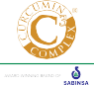

Supplysidewest.com/register

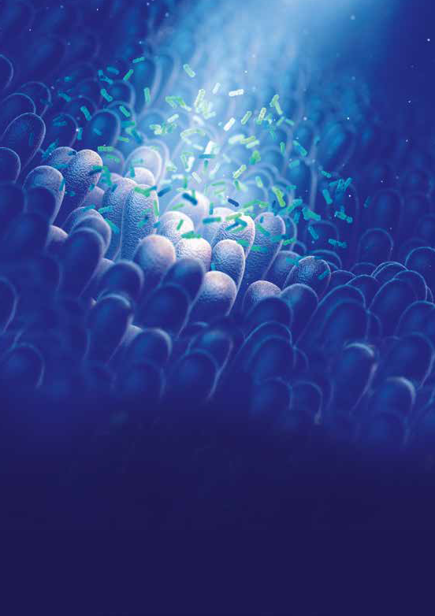

Probiotics like nobody else
Probiotical is the expert in probiotics and driving innovation since 1985.
From strain selection, advanced R&D, production of strains to finished product, with extensive experience in stability, high quality and demonstrated efficacy
in a lot of different functionalities

rdio
a lo

 
                                 
                  

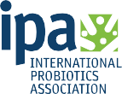

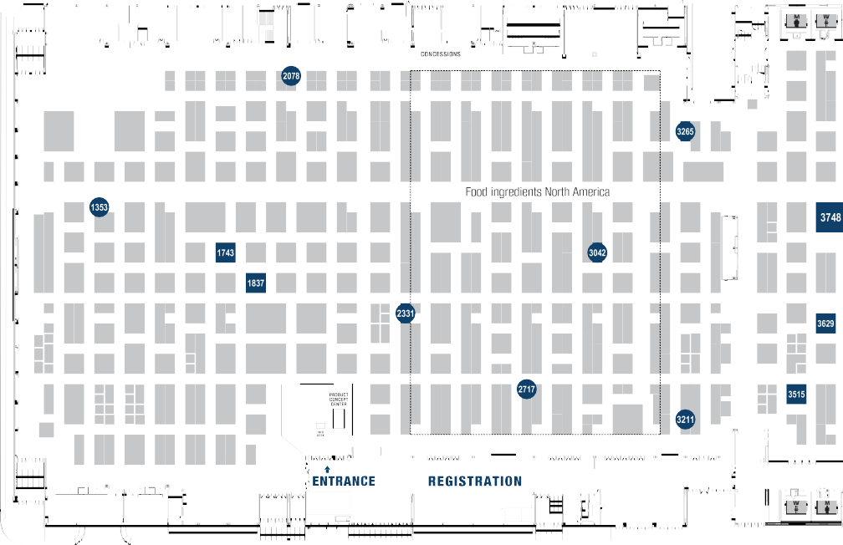
Probiotics Resource Center

SUPPLYSIDE® WEST 2019

Fluid Air | 5646-A |  | BioCC | 5646-F
Blis™ | 5646-B |  | Prenexus Health | 5646-G
MeriCal | 5646-C |  | RNI Consulting | 5646-H
Amin Talati Wasserman | 5646-D |  | International Probiotics Association | 5646-I
UAS Labs | 5646-E |  | Nutrasource | 5646-J

14 | SSW Floor Map

SupplyWSEidSTe'I

Food ingredients
'IJI'
North America

- October 15-19, 2019 · Expo Hall 17 & 1B Q Mandalay Bay, Las Vegas

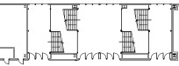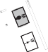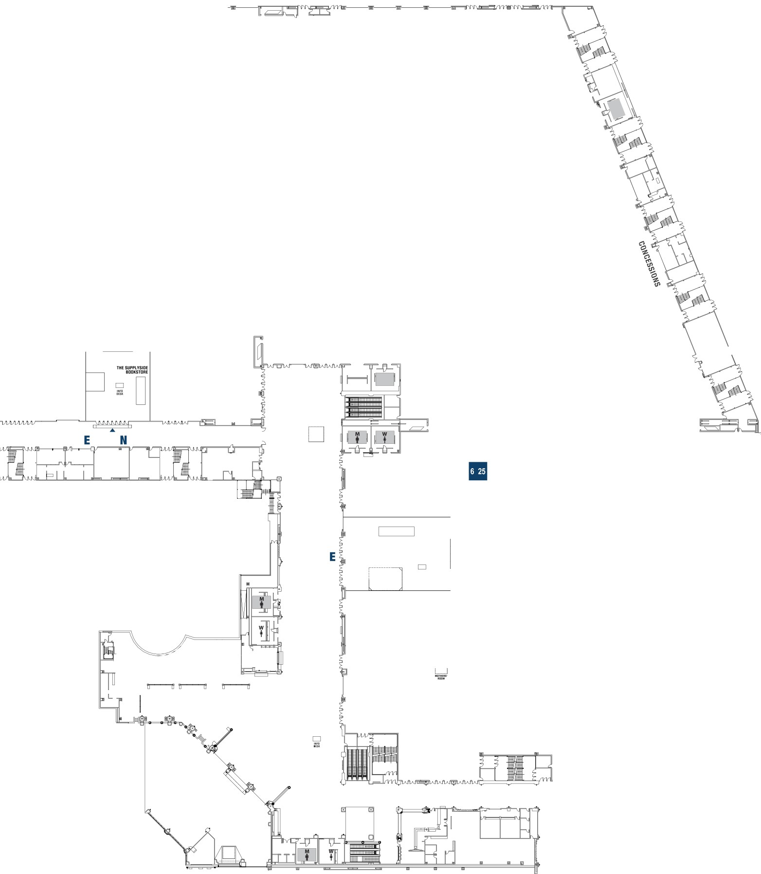• • •

• ••
II ■
Ill
■

■■• • •

■
•

SSW Floor Map | 15

IPA Member Probiotics Trail
SUPPLYSIDE® WEST 2019

Amin Talati Wasserman | 5646-D |  | Lesaffre International | 4837
AB-Biotics SA / Kaneka | 1743 |  | MeriCal | 5646-C
ADM Protexin | 3265 |  | MIDI Labs | 5728
AIDP | 4321 |  | Morinaga Milk Industry | 3042
Atlantia Food Clinical Trials | 5171 |  | MSPrebiotics | 4880
Bened Biomedical | 1353 |  | NSF International | 3629
Bifodan Inc. | 6525 |  | Nutralliance | 5751
BIO-CAT Microbials | 4567 |  | Nutrasource | 5646-J
BioCC | 5646-F |  | Prenexus Health | 5646-G
Blis™ | 5646-B |  | Probi | 4581
Catherych - Proenzymes | 2717 |  | Probiotical Healthcare | 4049
Centro Sperimentale del Latte | 7145 |  | RNI Consulting | 5646-H
Chr Hansen | 2078 |  | ROELMI HPC | 5024
Danisco USA | 3748 |  | Sabinsa Corporation | 4131
Deerland Probiotics & Enzymes | 4524 |  | Sanzyme Biologics | 7247
DSM | 4121 |  | Sirio Pharma | 4958
Eurofins | 6571 |  | Specialty Enzymes & Probiotics | 5373
Fluid Air | 5646-A |  | Synbio Tech | 3965
HSO Health Care | 7145-A |  | UAS Labs | 5646-E
Ingredients By Nature | 1837 |  | Unique Biotech | 3211
International Probiotics Association | 5646-I |  | US Pharma Lab | 4666
Intrinsic Organics | 5646 |  | VDF FutureCeuticals | 4759
Jiangsu Wecare Biotechnology | 2331 |  | Vitaquest International | 3943-C
Kerry Taste & Nutrition | 3515 |  | Viva5Corp | 5359
KGK Science | 5571 |  | Winclove Probiotics | 5482
Lallemand Health Solutions | 3865

16 | IPA Member Probiotics Trail

EDUCATION
IPA INSIGHTS

Education is a relatively new but important area of focus for the International Probiotics Association. The main objective is to be visible and provide credible probiotic information and tools to many stakeholders. From industry experts, health associations, universities, healthcare professionals to journalists and consumers; all will be able to benefit and draw from the infor- mation provided by the IPA and its Education & Communication Committee (ECC).

The objective is to build a solid and dependable go-to platform for sharing purposes. Learning and understanding the basics of probiotics are fundamen- tal and can be used for personal purposes or leveraged for amplification of the key messages to others. Having a common voice is so important to avoid confusion and the spread of untrue principles.

Current projects of the IPA ECC include offering educational webinars, the creation of infographics on various topics, the participation at impactful indus- try and healthcare professional events only to name a few. Liaising with IPA members is a priority in order to funnel their needs to the Committee and in turn collaborating with these members for execution.

Danielle Moore, RD

SENIOR PROJECT MANAGER, IPA
danielle@internationalprobiotics.org www.internationalprobiotics.org

IPA Insights: Education | 17

The Floradapt™ Story
Floradapt™ are the only probiotics based on the unique approach of isolating the most effective strains to counter specific health targets. These patented strains are the result of a global search for strains that are put through a comprehensive clinical and in-vitro selection process.

Floradapt™ Cardio

Floradapt™ Baby Colic

Floradapt™ Intensive GI

Floradapt™ Digest Floradapt™ Urinary Tract

Floradapt™ Vaginal Health
Floradapt™ Mature Immune Defense
Floradapt™ Gum Health

Floradapt™ patented products are formulated with proprietary strains, backed by published clinical trials, and utilize actual trial dosage in the finished commercial product.

For more information visit:
www.floradapt.com

Visit booth #1743 at SSW

These statements have not been evaluated by the Food and Drug Administration. This product is not intended to diagnose, treat, cure or prevent any disease.

SCIENTIFIC DEVELOPMENT IPA INSIGHTS

Probiotic science is continually evolving. This is a fact that we should be proud of instead of fear. To this end, in order to grow and develop our scientific DNA, IPA has been working hard to understand what scientific topics are important to its membership and where we can add value. We’ve seen prominent examples during 2019 that have had and will continue to have impact on the probiotic industry, such as media coverage of positive and negative research, new and exciting probiotic studies being published, and the taxonomic reclassification of the Lactobacillus genus.

This latter subject is one of great importance for anyone in the probiotic space. IPA scientists will be presenting on the upcoming changes to the genus Lactobacillus in more detail during the, “Extending Your Reach in the Probiotics Space” on Saturday, October 19, 8:30-11:30am. They will explain what is happening, how and when it is happening, and why it is a good thing.

So be sure to stop by to ensure you are up-to-date with this seismic and historical occurrence. If you don’t make it, be sure to come and visit us at the Probiotics Resource Center (Booth #5646) during the SupplySide® West Show in Las Vegas with your question and/or to talk some more probiotic science!

Jessica ter Haar, Ph.D.

SCIENTIFIC AFFAIRS DIRECTOR, IPA
jessica@internationalprobiotics.org www.internationalprobiotics.org

IPA Insights: Scientific Development | 19

More than 53 million Probiotic Users (age 18+) Across the U.S.*
5%

Millennials | 41% | 59%
Generation X | 35% | 65%
Baby Boomers | 35% | 65%
Seniors

*254 Million U.S. Adults 18+
31%
44%
19%

Probiotic Users are More Likely to Be College Grads & Have a Higher Income
Education Annual Median Income
41%

4 Year College Degree / Post Grad Degree
Total U.S. Adults
U.S. Probiotic Users

32%
U.S. Probiotic Users | All U.S. Adults
$71,940 | $62,720

21% of U.S. Consumers Take Probiotics

Probiotic Users Are Loyal Consumers Who Are More Concerned For Quality Over Price
vs.

U.S. Probiotics User
U.S. Adult Supplement User

Base their supplement purchase on product quality

74%

62%

Purchase the highest quality supplements even if they cost more

55%

41%

Are loyal to the supplement brands they use and regularly buy the same brand

65%

53%

Based on the Natural Marketing Institute’s Global Supplement/OTC/Rx Database™ (SORD) 2019

20 | IPA Infographics

Probiotic Users are Twice as Likely to Shop for Vitamins & Supplements at Health Food Stores*
Place of Purchase U.S. Probiotics |  |  | U.S. Adult
 | User |  | Supplement user
Mass Merchandiser (e.g., Walmart, K-mart, Target) | 59% | vs. | 49%
Drug Store / Pharmacy | 42% | vs. | 33%
Internet (e.g., Amazon, iHerb, Bodybuilding.com) | 37% | vs. | 22%
Traditional Grocery Store / Supermarket | 25% | vs. | 22%
Warehouse / Club Store (e.g., Sam’s, Costco) | 23% | vs. | 17%
*Total U.S. Supplement Users

Internet Shopping is a Growing Opportunity to Reach More Probiotic Consumer

Probiotic Users Worry More About False Claims and Ingredient Content – A Certification May Add Value
U.S. Probiotics User vs. Total U.S. Adult

74%

66%

I’m concerned that some supplements are based on false claims of health benefits

I’m concerned that some supplements are based on false claims of ingredient content

70%

63%

I worry about how a dietary supplement is made

64%

55%
and if it contains tainted or illegal ingredients

68% of U.S.  Probiotic Users | 45% of U.S.  Probiotic Users | More than half of U.S. Probiotic Users
Are concerned about the | Indicate increased usage | Wish their doctor provided
negative side effects of | & purchase of nutritional | suggestions on prevention
prescription medications | supplements over the past | of health issues rather than
 | 5 years | just treatment
vs. 59% non-probiotic users | vs. 25% of non-probiotic users | vs. 4 in 10 non-probiotic users

Based on the Natural Marketing Institute’s Global Supplement/OTC/Rx Database™ (SORD) 2019
6 in 10 U.S.
Probiotic Users

Feel confident in their knowledge of supplement usage

vs. 3 in 10 non-probiotic users

IPA Infographics | 21

7.1 Billion
US$ retail value of global probiotic supplements
in 2023
26%

Probiotic supplement growth from 2018 to 2023

21%
Total probiotic yoghurt growth from 2018 to 2023

In 2018, Global Probiotics Supplements sales surpassed
USD $5.6 Billion
In 2018, Global Probiotics Yoghurts sales surpassed
USD $31 Billion

USD $43.8 Billion
The World Retail Value of consumer consumption in 2018

The research from Euromonitor International is part of a global strategic intelligence that offers a complete picture of the commercial environment including but not limited to; market analysis, markets share, distribution channels, forecasting and much more.
“2018 Market Data Is Approximated Based On Data Obtained From Various Sources.”

22 | IPA Infographics

www.internationalprobiotics.org
info@internationalprobiotics.org

Nutralliance
Stability Enhanced Probiotics
Using Quadruple-Coated Technology
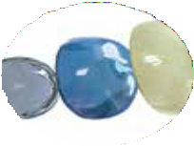Patented Quadruple-Coated

BIOSCIENCE
Probiotics
Lactobacillus I Bifidobacterium I Bacillus
Single Strain to Multi-Strain Probiotic Blends
NUTRALLIANCE
info@nutralliance.com
Toll Free: 844.410.1400 • Office: 714.694.1400
nutralliance.com
VISIT US AT BOOTH 5751

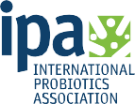
IPA’S GLOBAL PRESENCE
105 MEMBER COMPANIES STRONG
AS OF SEPTEMBER 1st, 2019
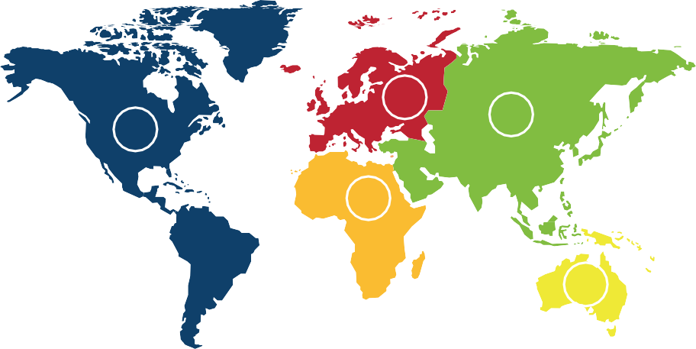
25
57
15
4
4
ASK US ABOUT JOINING TODAY!

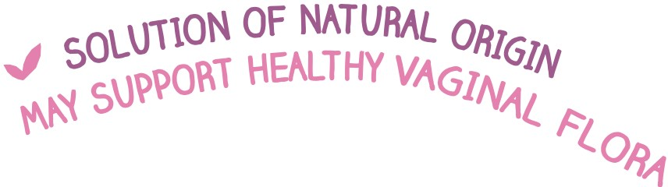

The breakthrough
for complete intestinal support

I

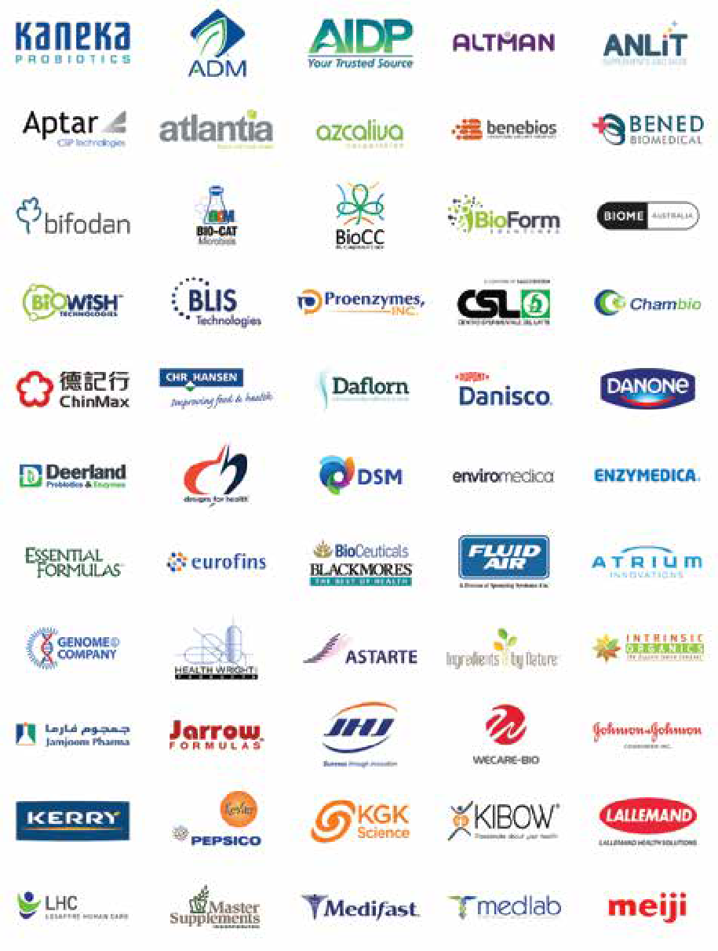
Current as of September 1, 2019
IPA Current Member Companies | 25

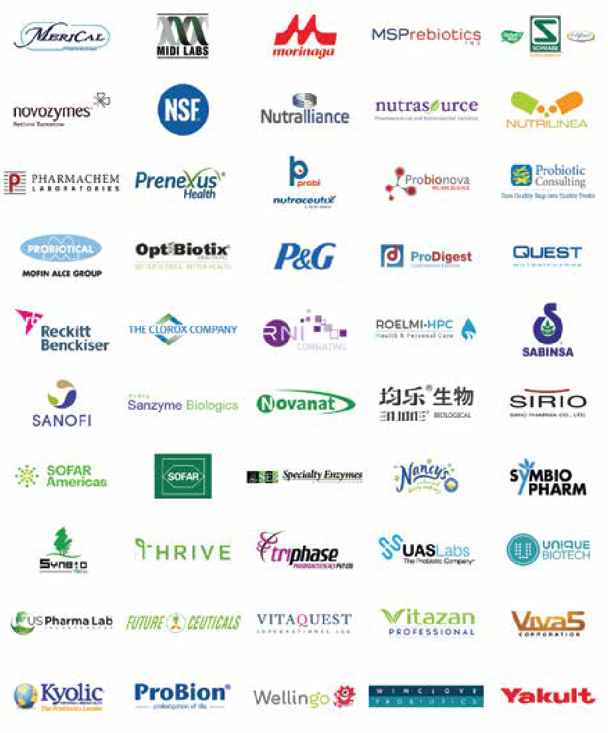
26 | IPA Current Member Companies Current as of September 1, 2019

George Paraskevakos, MBA
EXECUTIVE DIRECTOR, IPA
George has been involved with the probiotic industry since 2007 where he served in various roles from business development to account management with a globally recognized probiotic producer. During this time, he also served on the IPA Board of Directors (BoD) and had two (2) mandates as President before taking on the association’s leadership role as Executive Director in 2015. His passion for the probiotic industry is unequivocal and his persistence to have IPA continue being The Global Voice of Probiotics® has taken the association from 40 members when he took on the role to now over 100 international companies under his tutelage. George represents the International Probiotics Association in the media, to all probiotic industry stakeholders including government agencies and Codex, and in appearances at conventions, conferences, and other symposiums.

Danielle Moore, RD
SENIOR PROJECT MANAGER, IPA
Danielle Moore has more than 25 years of experience in the food (Danone Canada, Nestlé Nutrition) and pharmaceutical (Abbott Nutrition) industries. Dietitian by training, she obtained her bachelor’s degree in food science from McGill University and is a member of Dietitians of Canada and the Quebec Order of Professional Dietitians (OPDQ). Throughout her career, Danielle has participated in developing and implementing numerous education projects and tools especial- ly geared towards healthcare professionals. Major fields of interest are probiotics and prebiotics, the microbiota as well as nutrition and nutraceuticals in general. Danielle is currently Business Development Consultant at DM Nutrition and is involved with the International Probiotic Association as Project Manager.

Jessica ter Haar, Ph.D.
SCIENTIFIC AFFAIRS DIRECTOR, IPA
Jessica ter Haar (née Younes) joined IPA’s team as Scientific Director in September 2018; she was formerly a Microbiome Science Liaison and Business Developer at Winclove B.V. in Amsterdam. Jessica is specialized in women’s health and probiotics and holds a doctorate degree from the University of Groningen (the Netherlands) in medical microbiology and a Masters in Nutrition and Nutraceutical Sciences (University of Guelph). Her mandate with the IPA is help craft and define a more concrete scientific identity for global and regional sectors, supporting member companies and other committees as needed and driving a proactive scientific agenda. When she is not absorbed with probiotic science, Jessica can be found diligently working on improving the microbiomes of her young family in the most stunning place in the world, the land of a thousand lakes: Canada.

Elisa Fernández, B.Sc.
MARKETING MANAGER – EVENTS & CERTIFICATIONS,
Nutrasource Pharmaceutical & Nutraceutical Services
Elisa Fernández received a Bachelor of Science in Anatomy & Cellular Biology, as well as Minor in Neuropsychology from McGill University in 2010. In 2014, Elisa joined probiotic ingredient manufacturer Lallemand Health Solutions where she held three positions over 3 years – Internal Sales Representative, Scientific Representative, and finally Key Account Manager – Oceania. In 2017, with her new found passion for the probiotics Industry, Elisa joined forces with the International Probiotics Association as Director of Member Relations & Communications to focus on IPA’s new strategy as The Global Voice of Probiotics®. With science & quality being at the forefront of the probiotics industry, it was a natural transition to move towards a renown Clinical Research Organization, Nutrasource Pharmaceutical & Nutraceutical Services, for the next step in her career as Marketing Manager – Events & Certifications.

IPA Probiotics Guide Contributors | 27

SIRIO
Probiotics your way!
With Multi-dosage Forms

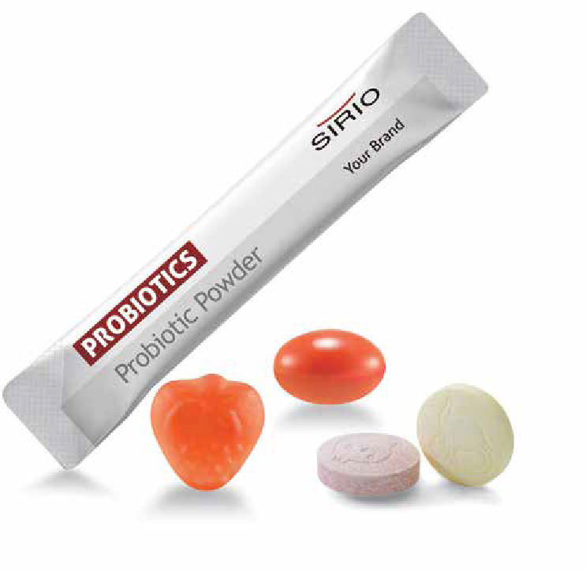<

L
Potent

_j

SIRIO PHARMA
Tel: +1 949 679 2883, +86 754 8688 8688
Ema il: ka rla @sir io .cn , int l@si rio . cn
www. sirio pharm.com
Booth #4958

